# Image_0OSM WORKSHOP EVALUATION INTERMEDIATE RESULT

**Date: 3 – 5 December 2012**

**Location: Hotel Santika, Surabaya**

**No. of participants: 11**

## 1. Raw Scores

Rating scale 1 – 4 (Don’t Understand – Very Understand)

|  |  |
| --- | --- |
| **Evaluations** | **Score** |
| **GIS Software** |  |
| OpenStreetMap | 3.09 |
| JOSM | 3.09 |
| Quantum GIS | 3.45 |

Rating scale 1 – 5 (Very Bad – Excellent)

|  |  |
| --- | --- |
| **Workshop and Materials** |  |
| Pace and structure | 3.64 |
| Quality of reference materials | 3.82 |
| Clarity of the Content | 3.55 |
| Relevance of course content | 3.73 |
| Organization/Structure | 3.64 |
| Content met expectations | 3.45 |
| Appropiate Time Allocated | 3.45 |
| **Sessions** |  |
| Application for Imagery Offset | 3.00 |
| Explaining quality and validation data in JOSM | 3.09 |
| Explaining and practice editing more details in JOSM | 3.18 |
| Completing conflict in JOSM | 3.45 |
| Create XML Presets | 3.64 |
| Using Private DataStore | 3.27 |
| Using Wiki OpenStreetMap | 3.73 |
| Discussions about the training | 3.64 |
| **Instructors** |  |
| Teaching methods | 3.55 |
| Quality of answers to questions | 3.27 |
| Knowledge of Topic | 3.64 |
| Closeness to the Participants | 4.27 |
| Clear and Understandable | 3.45 |
| Able to motivate the participants | 3.36 |

## 2. Charts

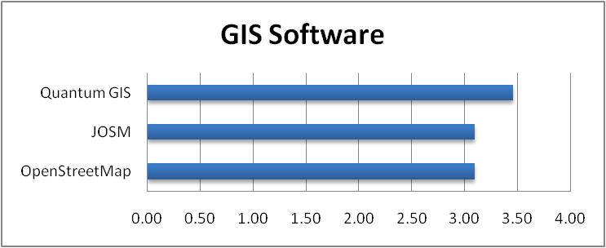

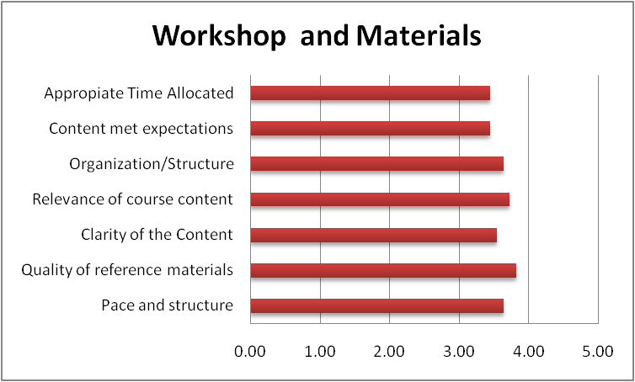

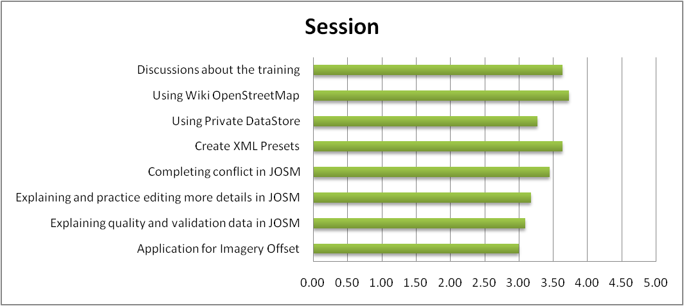

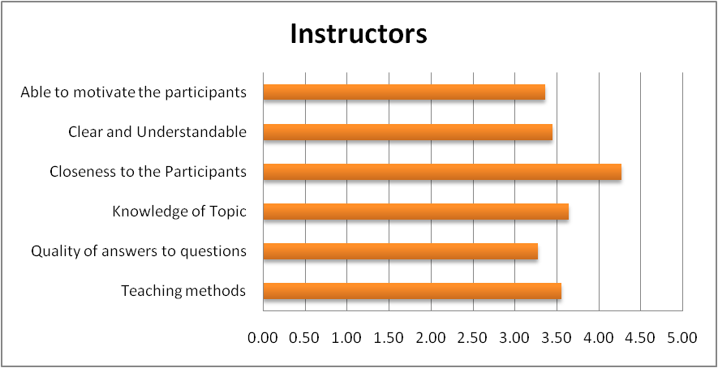

## 3. General comments

1. Can give additional knowledge for the implementation of the tasks
2. Can be directly practice
3. Give an introduction on the use of open source by osm
4. Effective and time-efficiency
5. Number of trainer that many new participants that facilitate the early stages
6. Handouts less comprehensible
7. Instructors is not a maximum because of time
8. Between trainer and participants more familiar outside the classroom so they can share material
9. Yes, very supportive and give insight into better performance and practical
10. Much needed for data collection in the field
11. OpenStreetMap very useful and free
12. Please adjusted the level of participants, not least of which have the capability of GIS and IT
13. Good quality and easy to understand